Appendix A. Figures
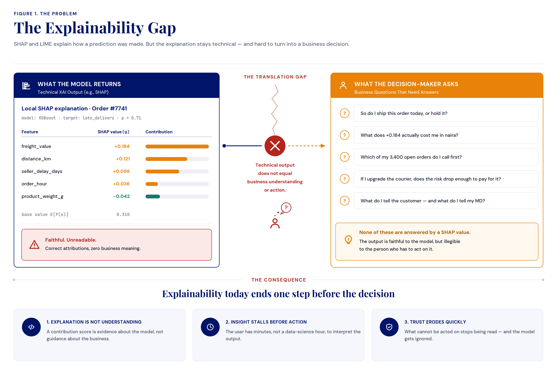
Figure 1. The Explainability Gap
Note. The figure highlights the disconnect between what existing XAI methods explain and what decision-makers need to know. Technical explanations faithfully describe the factors influencing a prediction, whereas business users seek answers about operational impact, financial consequences, risk, and recommended actions. This translation gap means that explainability often stops at model interpretation rather than supporting informed business decisions, motivating the need for a Business Language Layer.

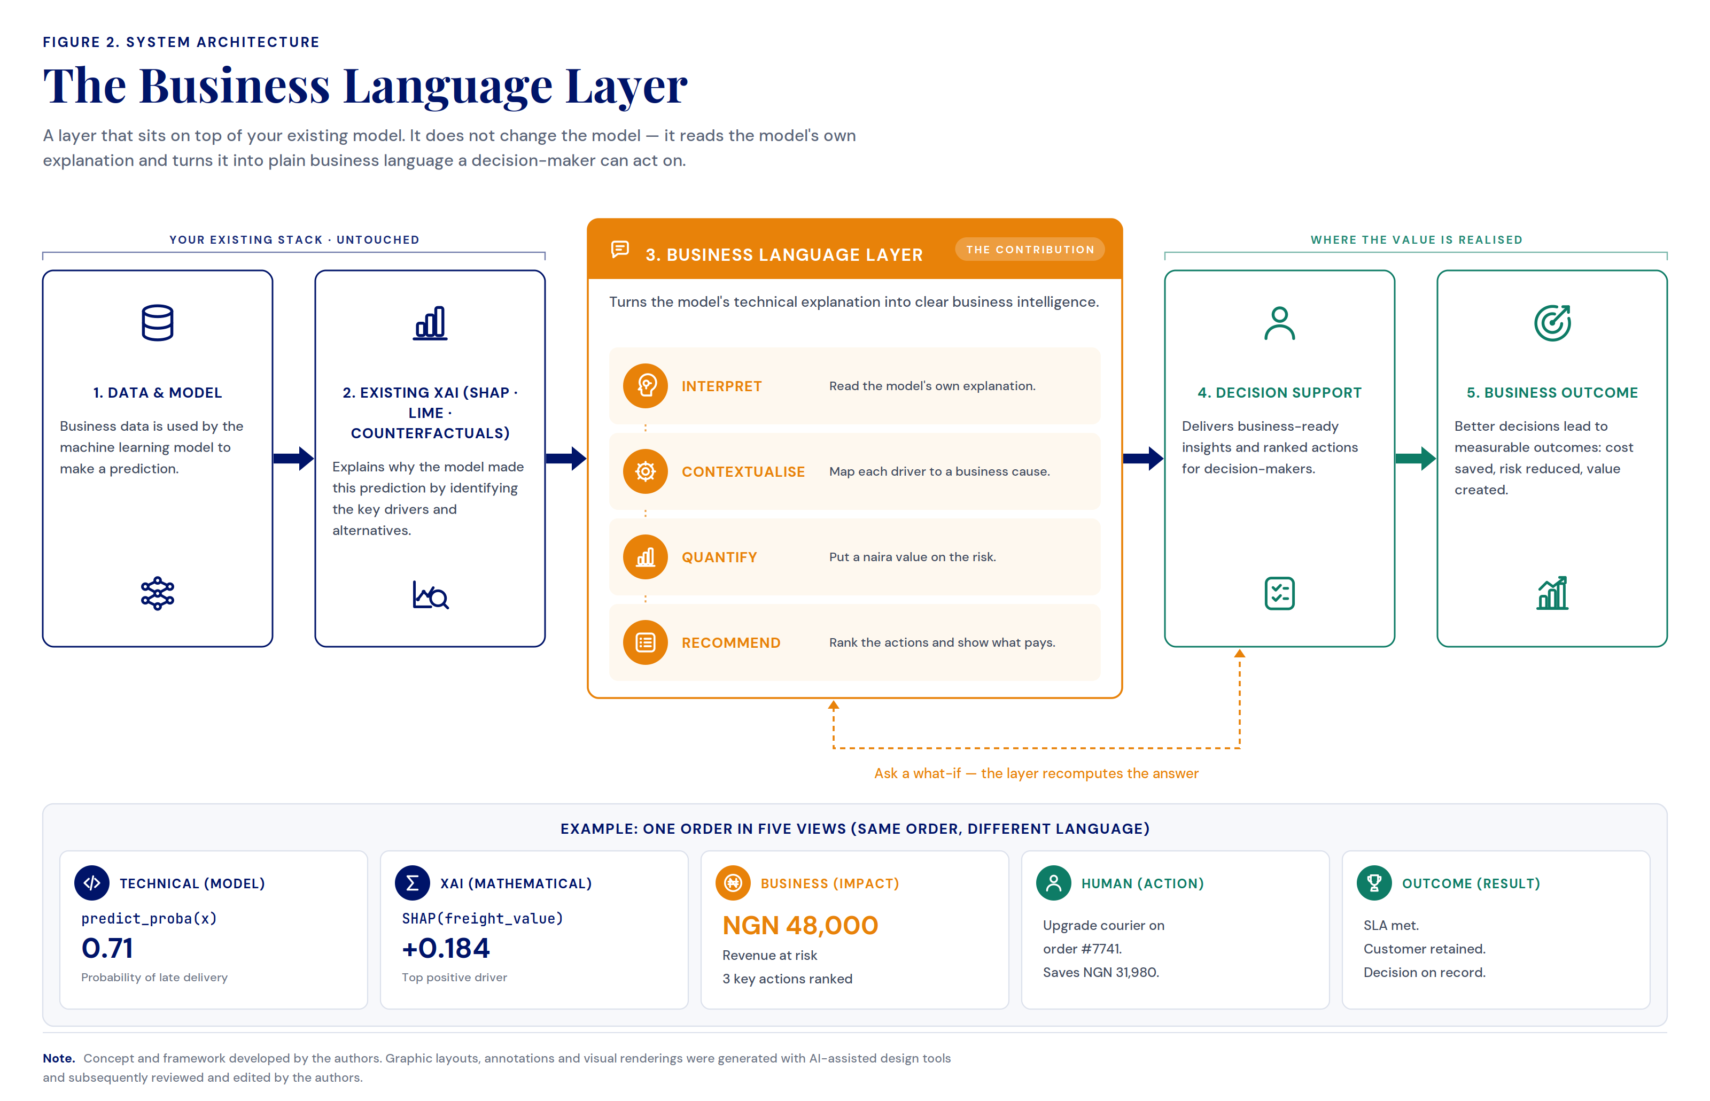
Figure 2. The Business Language Layer
Note. The figure presents the architecture of the Business Language Layer and its place within an existing analytics pipeline. The layer sits on top of the model and its explainer, leaving both untouched, and reads the explanation they produce. Through four functions — interpret, contextualise, quantify, and recommend — it re-expresses that technical explanation as business intelligence, carrying a single prediction from raw model output through to a decision and its outcome. The example strip shows the same order described in five successive registers, illustrating how meaning is preserved while the language shifts from machine to business.

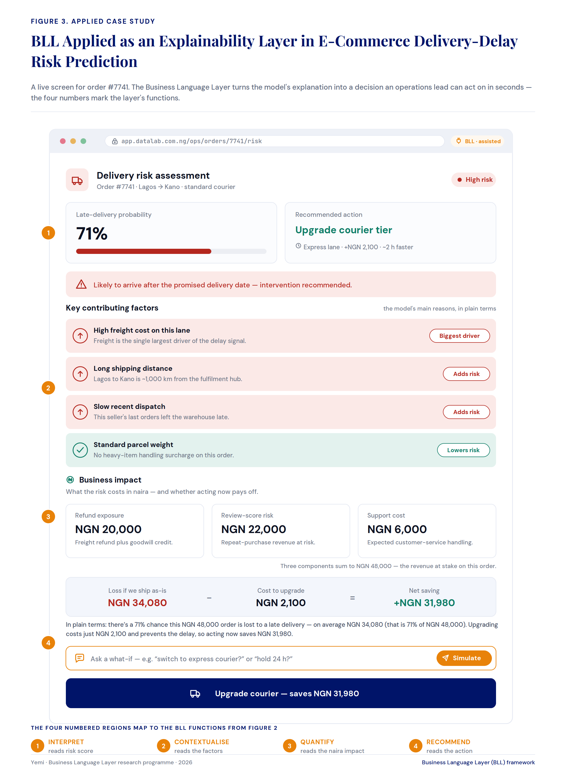
Figure 3. BLL Applied as an Explainability Layer in E-Commerce Delivery-Delay Risk Prediction
Note. The figure demonstrates the Business Language Layer operating as a live decision surface for a single order. The same model output that appears as raw contribution scores elsewhere is here re-expressed as a risk level, a set of plainly worded contributing factors, a monetised business impact, and a single recommended action with its net saving. Each numbered region corresponds to one of the four layer functions — interpret, contextualise, quantify, and recommend — showing how a technical explanation is progressively translated into a decision an operations lead can act on within seconds. The interface illustrates that explainability, once passed through the layer, becomes not merely interpretable but directly actionable at the point of decision.

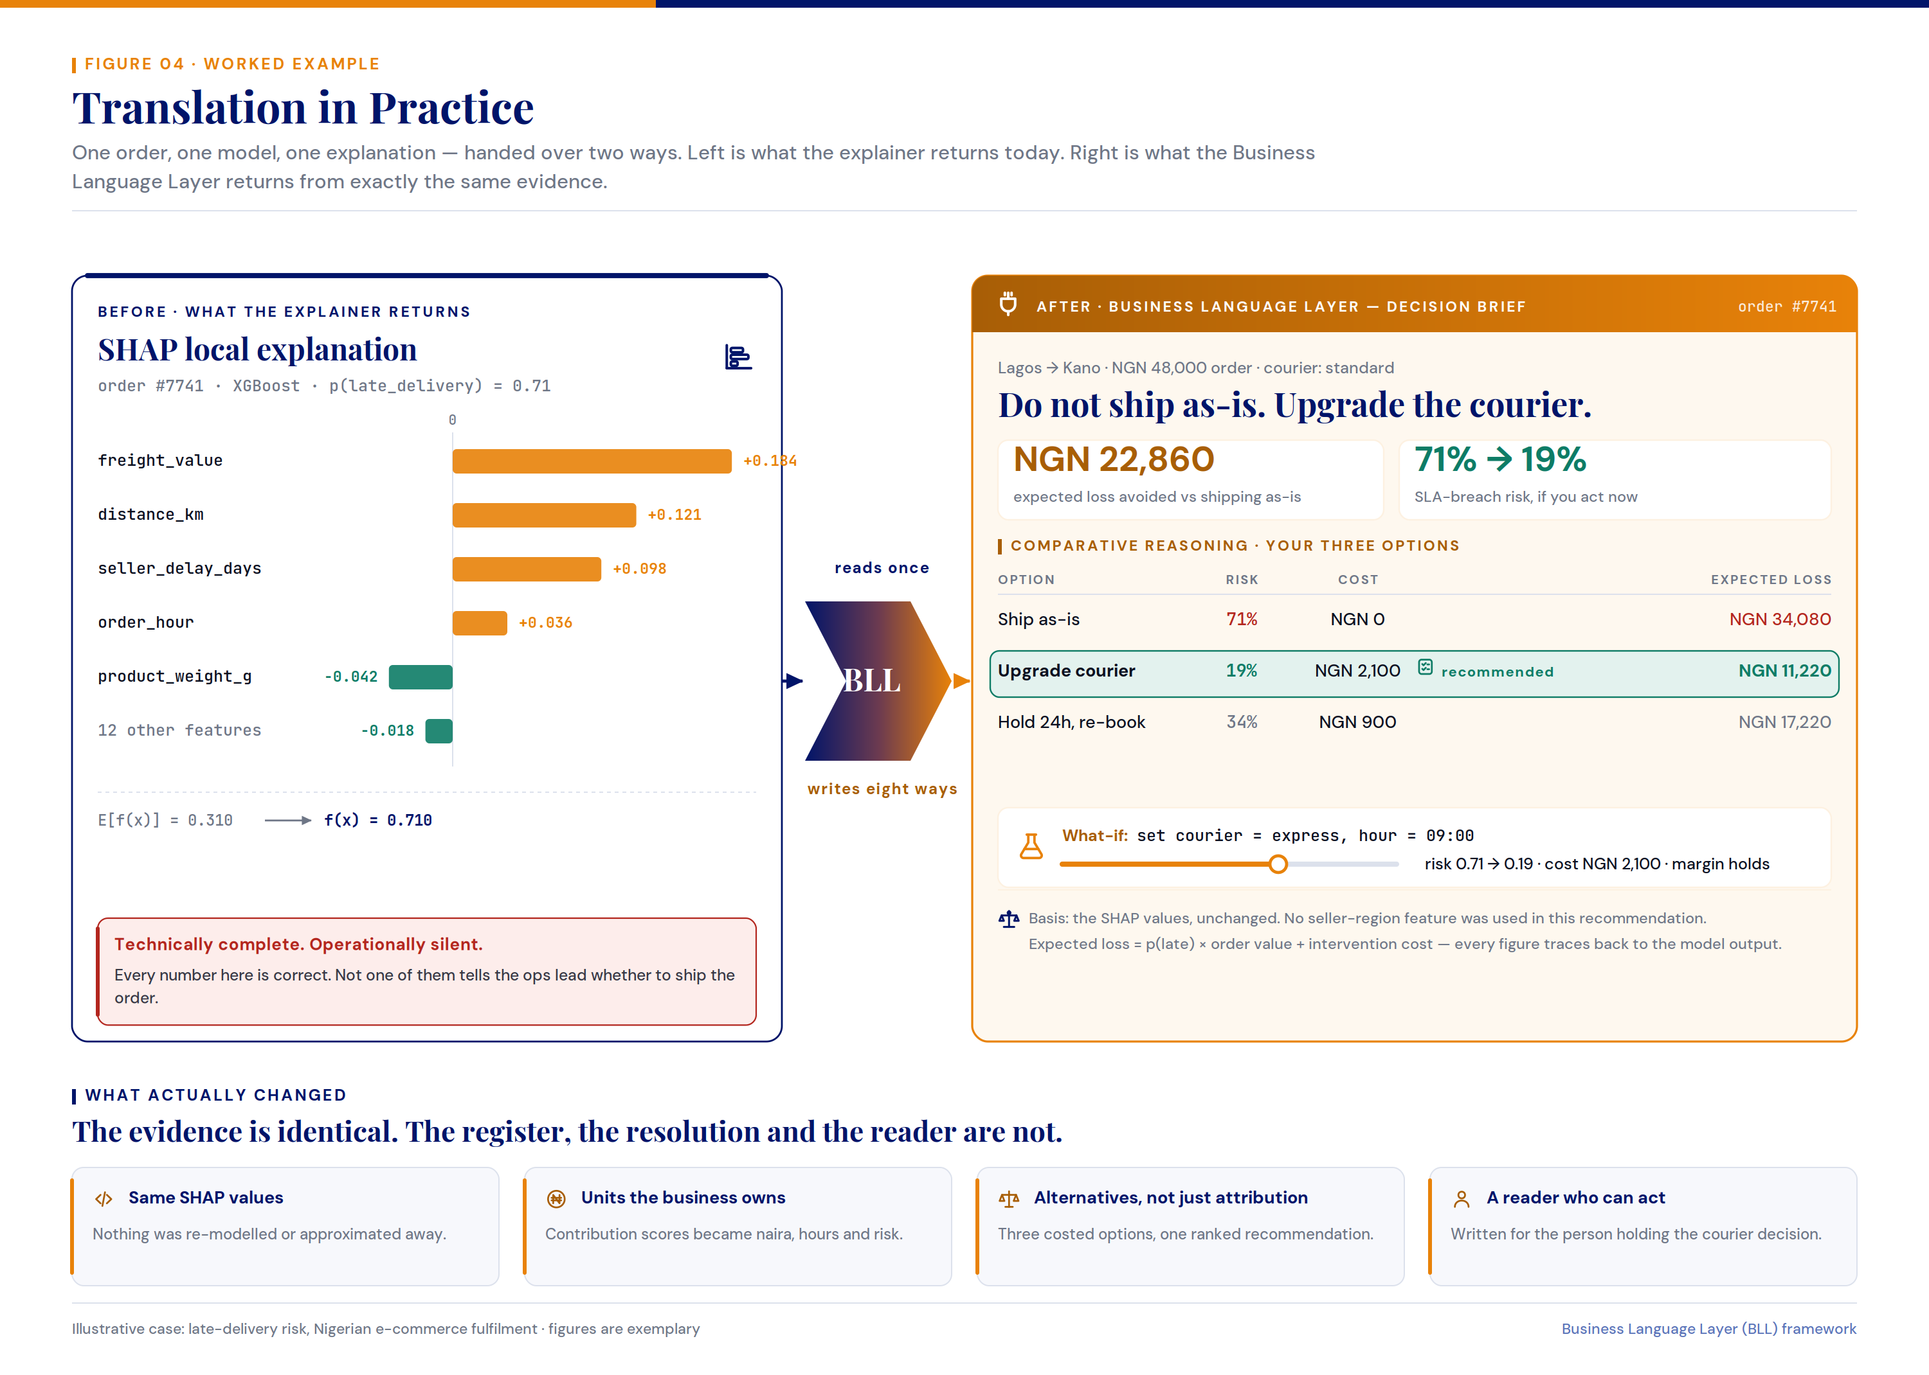
Figure 4. Translation in Practice
Note. The figure contrasts what the explainer returns today with what the Business Language Layer produces from the same evidence. On the left, a technically complete SHAP explanation lists the factors behind a late-delivery prediction but offers no guidance on what to do. On the right, the layer converts that identical explanation into a decision brief: a plainly stated recommendation, a set of costed alternatives, and the monetary consequence of each. The comparison shows that the underlying evidence is unchanged — only its register, its resolution, and its intended reader differ.

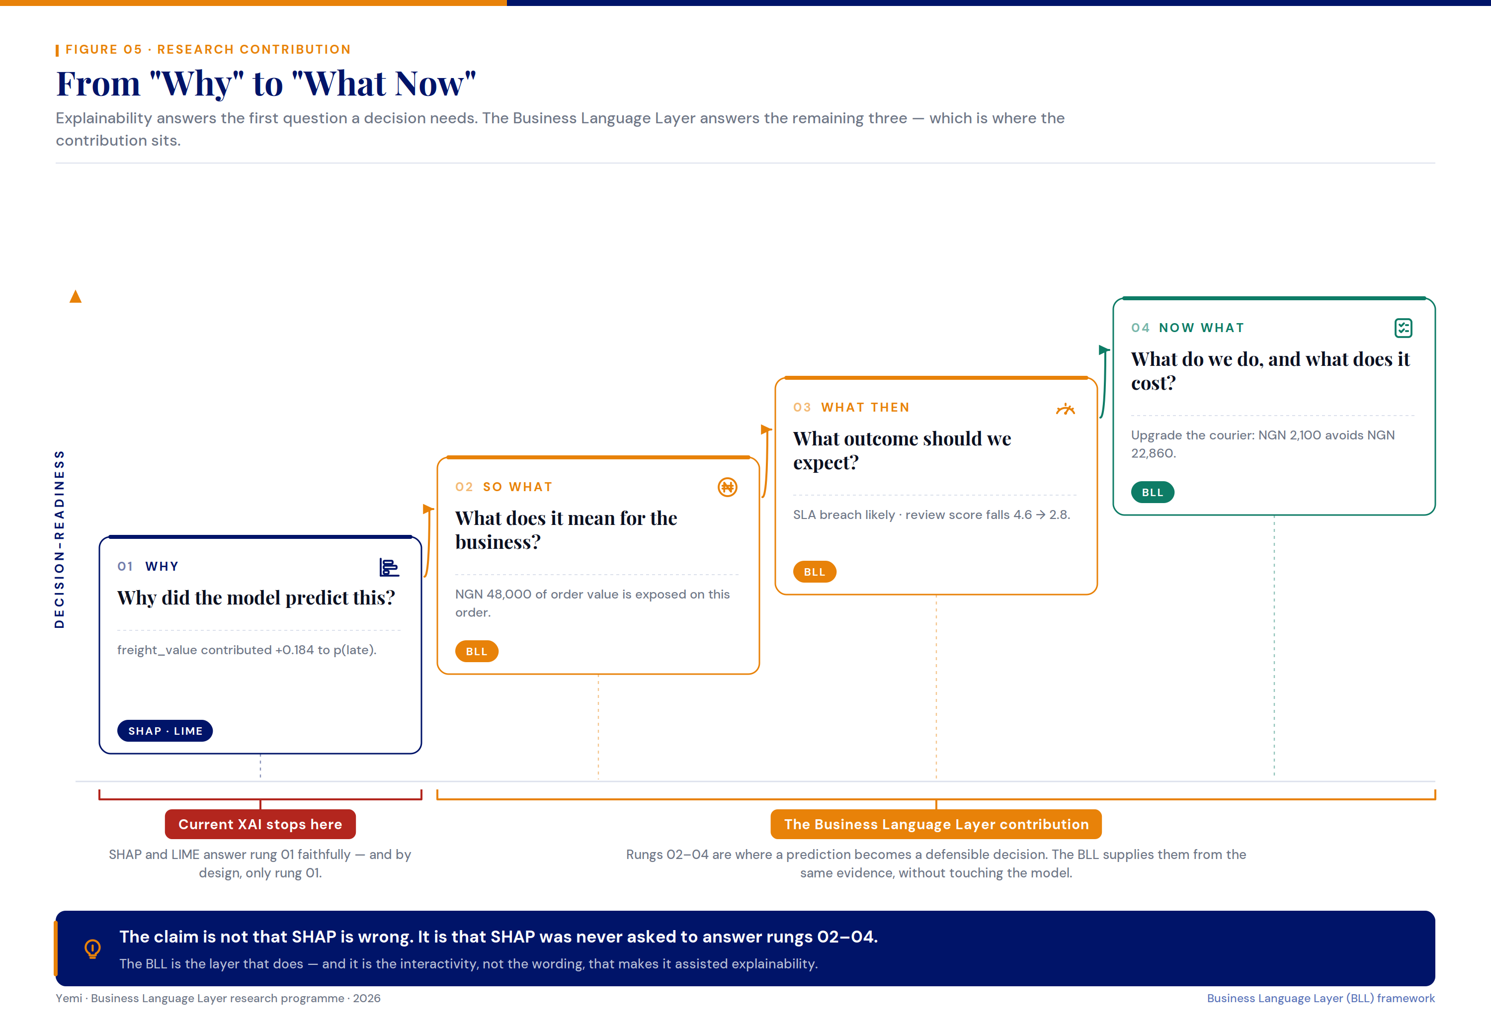
Figure 5. From "Why" to "What Now"
Note. The figure frames explainability as a sequence of questions a decision requires — why, so what, what then, and what now. Existing XAI methods answer only the first, describing why a model made its prediction. The Business Language Layer supplies the remaining three, translating that same explanation into business meaning, expected outcome, and a costed recommendation. The figure positions the contribution not as a correction of SHAP or LIME, but as the layer that carries a faithful explanation the rest of the way to a defensible decision.

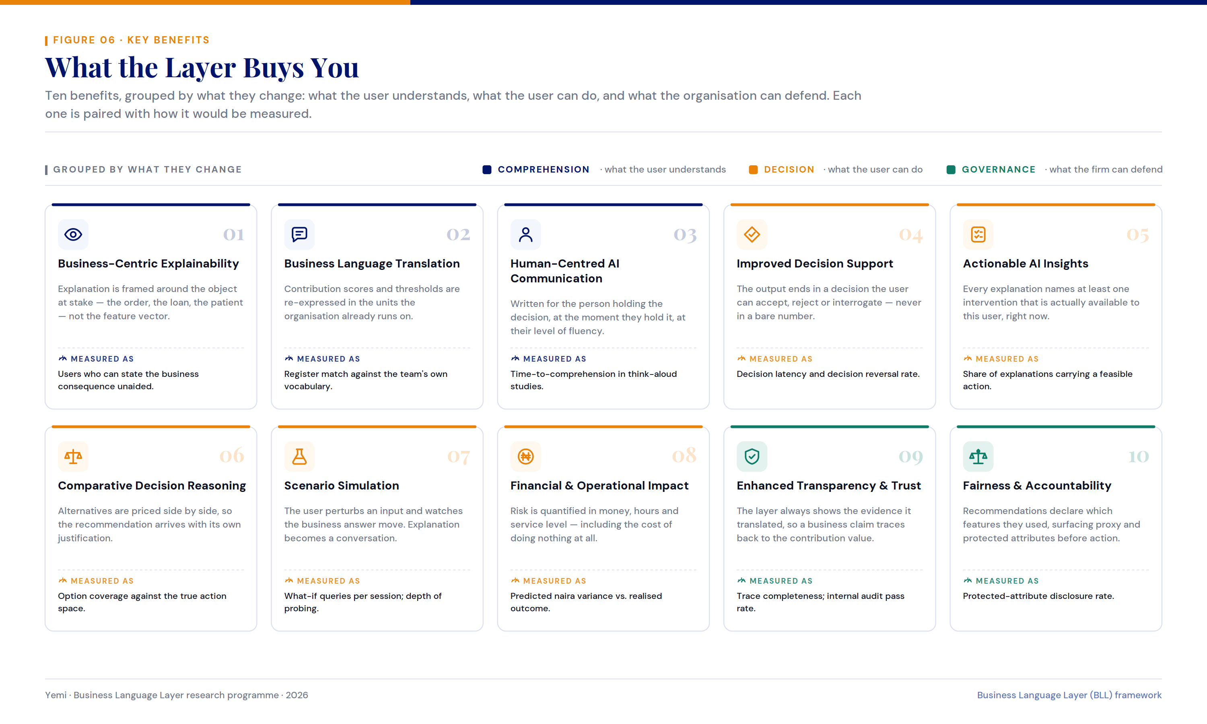
Figure 6. What the Layer Buys You
Note. The figure summarises the main benefits of the Business Language Layer, grouped by what each one changes: what the user understands, what the user can do, and what the organisation can defend. Each benefit is paired with a simple way to measure it, showing that the layer’s value extends beyond understanding a prediction to supporting and accounting for the decisions that follow.

